Lab: JavaScript Basics
You can check your solutions in https://judge.softuni.org/Contests/5400/JavaScript-Basics-Lab

Multiply the Number by 2
Write a function that receives a number and prints as result that number multiplied by two.

Examples
Input | Output
2 | 4
5 | 10
20 | 40

Hints
Create a function called solve (or some other name). As parameters, it will receive a number num.
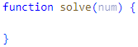
Print the result inside the function.
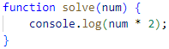
If you want to test your code locally, you need to call the function.
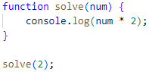

Student Information
You will be given 3 parameters – student name (string), age (number) and average grade (number). Your task is to print all the info about the student in the following format:
"Name: {student name}, Age: {student age}, Grade: {student grade}"
Note: The grade should be formatted to the second decimal point.

Examples
Input | Output
'John', 15, 5.54678 | Name: John, Age: 15, Grade: 5.55
'Steve', 16, 2.1426 | Name: Steve, Age: 16, Grade: 2.14
'Marry', 12, 6.00 | Name: Marry, Age: 12, Grade: 6.00

Hint
Use toFixed() method to format the grade.
First, receive the input
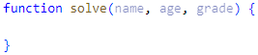
Then, print the output
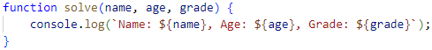

Excellent Grade
Write a function that receives a single number and checks if the grade is excellent or not.
If it is, print "Excellent", otherwise print "Not excellent".

Examples
Input | Output
5.50 | Excellent
4.35 | Not excellent

Hints
Check if the number given is greater or equal to 5.50 and print the corresponding result.
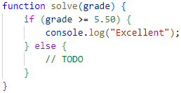

Month Printer
Write a program, that takes an integer as a parameter and prints the corresponding month. If the number is more than 12 or less than 1, print "Error!"

Input
You will receive a single number.

Output
If the number is within the boundaries, print the corresponding month, otherwise print "Error!"

Examples
Input | Output |  | Input | Output
2 | February |  | 13 | Error!

Math Operations
Write a JS function that takes two numbers and a string as input.

The string may be one of the following: '+', '-', '*', '/', '%', '**'.

Print on the console the result of the mathematical operation between both numbers and the operator you receive as a string.
The input comes as two numbers and a string argument, passed to your function.
The output should be printed on the console.

Examples
Input | Output
5, 6, '+' | 11
3, 5.5, '*' | 16.5

Hints
Write a function that receives three arguments.
Declare a variable named result that will keep your mathematical result.

Write down the switch command that will take the string from your input and depending on it, perform the mathematical logic between the two numbers.
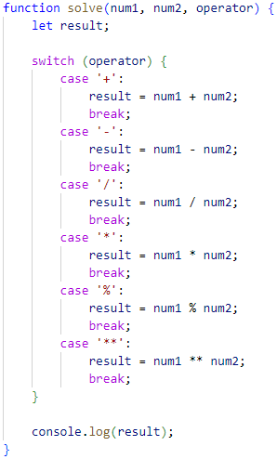
Print the result on the console.

Largest Number
Write a function that takes three number arguments as input and finds the largest of them.
Print the following text on the console: "The largest number is {number}.".
The input comes as three number arguments passed to your function.
The output should be printed to the console.

Example
Input | Output
5, -3, 16 | The largest number is 16.
-3, -5, -22.5 | The largest number is -3.

Hints
Write a function that receives three number arguments.
Declare a variable named result that will keep the result.
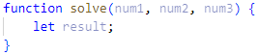
Make several checks to find out the largest of the three numbers.
Start with num1.
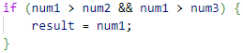
Do the same for the others.
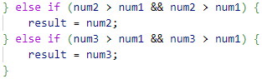
Print the result on the console.

Theatre Promotions
A theatre is doing a ticket sale, but they need a program to calculate the price of a single ticket. If the given age does not fit one of the categories, you should print "Error!". You can see the prices in the table below:
Day / Age | 0 <= age <= 18 | 18 < age <= 64 | 64 < age <= 122
Weekday | 12$ | 18$ | 12$
Weekend | 15$ | 20$ | 15$
Holiday | 5$ | 12$ | 10$

Input
The input comes in two parameters. The first one will be the type of day (string). The second is the age of the person (number).

Output
Print the price of the ticket according to the table, or "Error!" if the age is not in the table.

Constraints
- The age will be in the interval [-1000…1000].
- The type of day will always be valid.

Examples
Input | Output |  | Input | Output |  | Input | Output
'Weekday', 42 | 18$ |  | 'Holiday', -12 | Error! |  | 'Holiday', 15 | 5$

Circle Area
Write a function that takes a single argument as input. Check the type of input argument. If it is a number, assume it is the radius of a circle and calculate the circle area. Print the area rounded to two decimal places.
If the argument type is NOT a number, print the following text on the console:
"We can not calculate the circle area, because we received a {type of argument}."
The input comes as a single argument passed to your function.
The output should be printed on the console.

Example
Input | Output
5 | 78.54
'name' | We can not calculate the circle area, because we receive a string.

Hints
Write a function that receives a single argument.
Declare a variable named result that will keep your result.
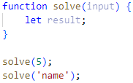
Check the type of the input argument with the typeof operator.
If the type is equal to number, calculate the circle area and print it on the console rounded to two decimal places. To do this, use the toFixed() method.
The Math.pow() function returns the base to the exponent power, that is, the base exponent. You can find more information about the area here:
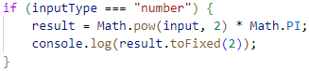
If the type is NOT a number, print the following text on the console:

Numbers from 1 to 5
Write a function that prints all the numbers from 1 to 5 (inclusive) each on a separate line.

Hints
Create a for loop starting from 1 and continuing until 5 and print the number.
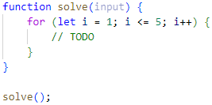

Numbers from M to N
Write a function that receives a number M and a number N (M will always be bigger than N). Print all numbers from M to N.

Examples
Input | Output
6, 2 | 6  5  4  3  2
4, 1 | 4  3  2  1

Hints
Use for or while loop and print the numbers.
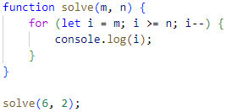

Sum First and Last Array Elements
Write a function that receives an array of numbers and prints the sum of the first and last element in that array.

Examples
Input | Output
[20, 30, 40] | 60
[10, 17, 22, 33] | 43
[11, 58, 69] | 80

Hints
You can access the last element in an array by subtracting 1 from its length:
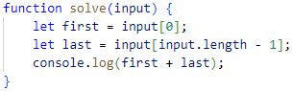

Reverse an Array of Numbers
Write a program, which receives a number n and an array of elements. Your task is to create a new array with n numbers from the original array, reverse it and print its elements on a single line, space-separated.

Examples
Input | Output
3, [10, 20, 30, 40, 50] | 30 20 10
4, [-1, 20, 99, 5] | 5 99 20 -1
2, [66, 43, 75, 89, 47] | 43 66

Hints
Use push() to add elements inside the new array.
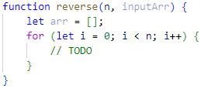
Print the output.
